SIMATS ENGINEERING (SAVEETHA SCHOOL OF ENGINEERING)
Department of Computer Science and Engineering

CO5 - ASSESSMENT TOOL 2 – Coding Challenge

Course Code: | DSA0404 | Course Title: | FUNDAMENTALS OF DATA  SCIENCE
CO Assessed: | CO5 –Coding Challenge | Assessment: | Assessment Tool 2– Coding Challenge
Weightage: | 40% of CIA | Total Marks: | 100
CO5 Statement: | To understand the concept of supervised and unsupervised methods in machine learning
Student Name: | B.Nikhila | Reg. No.: | 192472102
Section / Batch: | 2024 | Date: | 26-08-2026

Code of Conduct
I _B.Nikhila/192472102 (Name / Reg No) certify that this submission is my original work and that I have adhered to the guidelines specified for this assessment. I understand that any violation of academic integrity rules will result in disciplinary action.
Signature of the Student: _ B.Nikhila

Criteria | Weight age | Level 4 – Exemplary | Level 3 – Proficient | Level 2 – Developing | Level 1 – Beginning | Marks
Understanding of Case | 25 | Thorough  understanding; clearly identifies all key issues | Good understanding with most issues identified | Basic understanding; some issues missed | Poor understanding; problem not identified correctly
Application of Concepts | 25 | Effectively applies relevant concepts to analyze the case deeply | Applies appropriate concepts with minor gaps | Limited application of concepts | Fails to apply relevant concepts
Analysis | 20 | In-depth analysis with strong reasoning and insights | Good analysis with logical reasoning | Basic analysis with limited depth | Weak or no analysis; lacks reasoning
Solution Design | 20 | Innovative, feasible solutions with strong justification | Logical solutions with  adequate  justification | Basic solutions with weak justification | Incorrect or no solution provided
Clarity | 10 | Clear, well-structured, and easy to understand | Organized and understandable presentation | Limited clarity and structure | Poor clarity; difficult to understand

Q24. Implement L2-regularized logistic regression from scratch and demonstrate its effect on the decision boundary and
coefficient magnitudes for a dataset prone to overfitting (e.g., high-dimensional, few samples).

Source Code:
import numpy as np
import matplotlib.pyplot as plt
# Dataset: few samples, many features (overfitting prone)
np.random.seed(42)
X = np.random.randn(20, 10)
y = (X[:, 0] + X[:, 1] > 0).astype(int)
# Add bias
Xb = np.c_[np.ones(X.shape[0]), X]
# Sigmoid function
def sigmoid(z):
return 1 / (1 + np.exp(-z))
# Logistic Regression from scratch
def train(X, y, reg=0, lr=0.1, epochs=2000):
w = np.zeros(X.shape[1])
for _ in range(epochs):
p = sigmoid(X @ w)
gradient = X.T @ (p - y) / len(y)
# L2 regularization (do not regularize bias)
gradient[1:] += reg * w[1:]
w -= lr * gradient
return w
# Train without regularization
w_no_reg = train(Xb, y, reg=0)
# Train with L2 regularization
w_l2 = train(Xb, y, reg=1)
print("Coefficients without L2:")
print(w_no_reg)
print("\nCoefficients with L2:")
print(w_l2)
print("\nCoefficient magnitude:")
print("Without L2:", np.linalg.norm(w_no_reg[1:]))
print("With L2 :", np.linalg.norm(w_l2[1:]))
# Compare coefficient magnitudes
plt.figure(figsize=(8, 5))
plt.plot(np.abs(w_no_reg[1:]), 'o-', label="Without L2")
plt.plot(np.abs(w_l2[1:]), 'o-', label="With L2")
plt.xlabel("Feature")
plt.ylabel("Absolute coefficient")
plt.title("Effect of L2 Regularization")
plt.legend()
plt.grid()
plt.show()
# Decision boundary using first two features
def predict(x1, x2, w):
return sigmoid(w[0] + w[1] * x1 + w[2] * x2)
xx, yy = np.meshgrid(
np.linspace(X[:, 0].min()-1, X[:, 0].max()+1, 100),
np.linspace(X[:, 1].min()-1, X[:, 1].max()+1, 100)
)
Z1 = predict(xx, yy, w_no_reg)
Z2 = predict(xx, yy, w_l2)
plt.figure(figsize=(12, 5))
plt.subplot(1, 2, 1)
plt.contour(xx, yy, Z1, levels=[0.5])
plt.scatter(X[:, 0], X[:, 1], c=y)
plt.title("Without L2 Regularization")
plt.xlabel("Feature 1")
plt.ylabel("Feature 2")
plt.subplot(1, 2, 2)
plt.contour(xx, yy, Z2, levels=[0.5])
plt.scatter(X[:, 0], X[:, 1], c=y)
plt.title("With L2 Regularization")
plt.xlabel("Feature 1")
plt.ylabel("Feature 2")
plt.tight_layout()
plt.show()

OUTPUT:

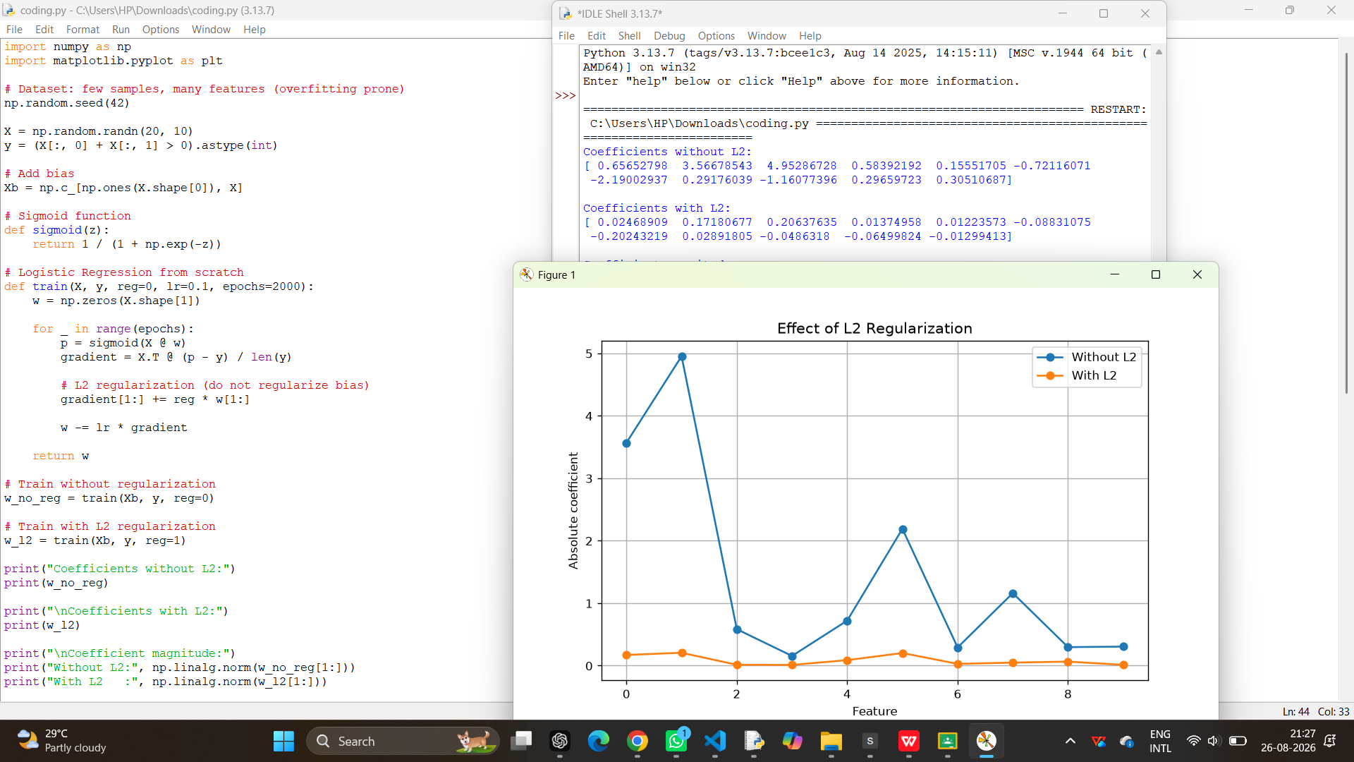

GEO TAG:

